# Name: Edwin Chen Grade ____/100

Use this template to submit the required screenshots for Lab 03. Each screenshot is worth 20 points. If your screenshots do not have the required information, are illegible, blurry, or unreadable, they will not receive credit. Any attempt to alter the information in the screenshots in any way is academic dishonesty, and you may fail the course.

Example: LR03_GArcoraci.doc.



All screenshots must be labeled, using the following titles.

**Figure 1** – Git Repository Verification

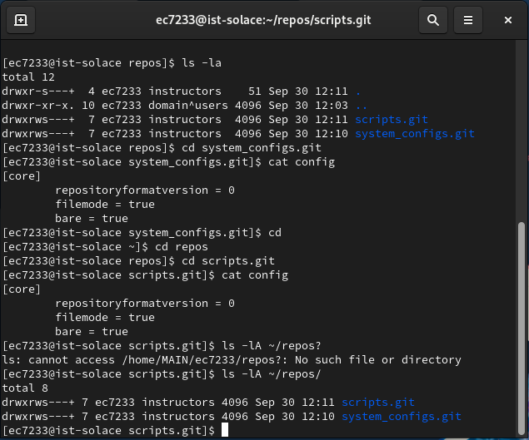

**Figure 2** – Git Log Revision History

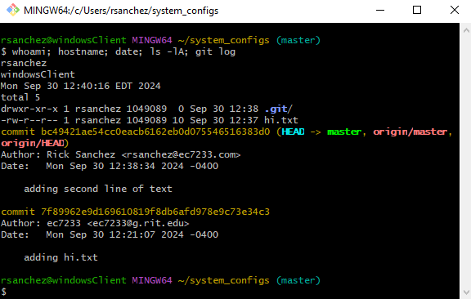

**Figure 3** – Git Merge Verification

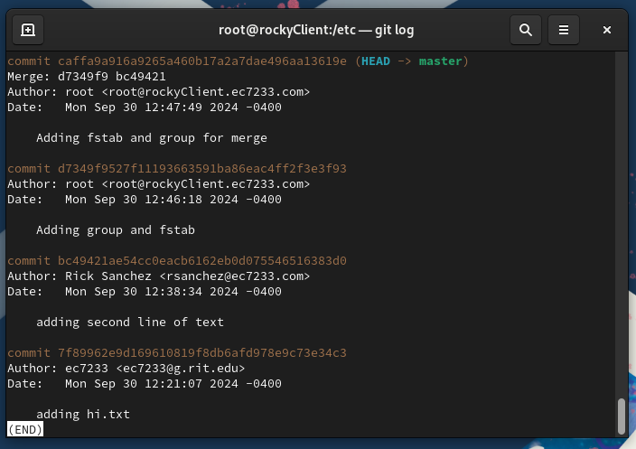

**Figure 4** – User Command History

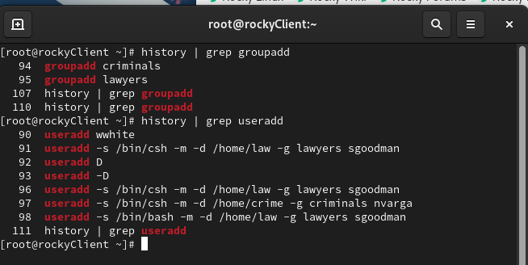

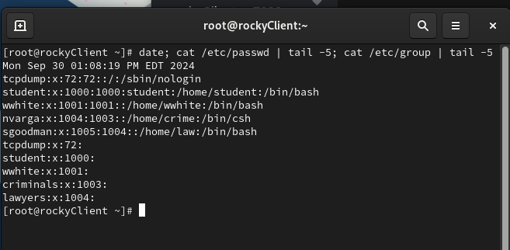

**Figure 5** – Root Password Change Verification

